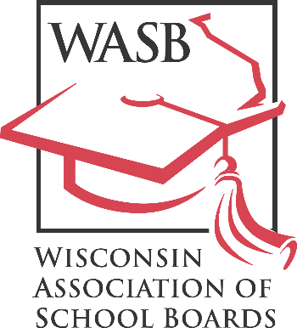
John H. Ashley, Executive Director
“Leadership in Public School Governance”

122 W. Washington Avenue, Madison, WI 53703
Phone: 608-257-2622 Fax: 608-257-8386
FOR IMMEDIATE RELEASE
[DATE]
Contact: Sheri Krause, WASB communications director
Phone: 608-512-1705

[SCHOOL DISTRICT] School Board Member Honored for Commitment to Professional Development

[SCHOOL DISTRICT NAME] school board member [BOARD MEMBER’S NAME] has been recognized by the Wisconsin Association of School Boards (WASB) for their commitment to professional development.

[BOARD MEMBER’S LAST NAME] has earned Level 5 recognition — the highest available — by attending training opportunities focused on student achievement and improving public education by the Wisconsin Association of School Boards and/or the National School Boards Association.

The WASB’s Member Recognition Program tracks the professional development of board members, who may be awarded one of five achievement levels based on a point system. Members receive points by attending the State Education Convention, participating in workshops and a variety of other professional development activities. To learn more, please visit our website.

Level 5 recognition is limited to the most active school board members in the state, a mark reached this year by only about a dozen of the more than 2,800 school board members statewide. Board members with Level 5 recognition have gone far beyond the requirements of school board membership in an effort to support the students in their community.

WASB Executive Director John Ashley recognizes [BOARD MEMBER’S LAST NAME]’s accomplishments.

“Board members begin their service with a desire to help children in their community reach their potential,” he said. “[BOARD MEMBER’S LAST NAME] has backed up that aspiration with hard work and dedication to learn how to be the best school board member they can be. They’re an example of the best of school board service in Wisconsin.”

The Wisconsin Association of School Boards is a nonprofit association that provides information and services to Wisconsin school boards in the areas of school law and policymaking, bargaining, legislation and leadership development.

