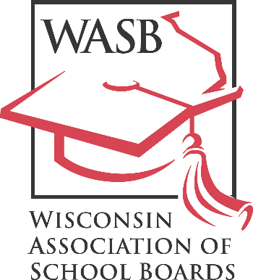
John H. Ashley, Executive Director
“Leadership in Public School Governance”

122 W. Washington Avenue, Madison, WI 53703
Phone: 608-257-2622 Fax: 608-257-8386
FOR IMMEDIATE RELEASE
[DATE]
Contact: Sheri Krause, WASB communications director
Phone: 608-512-1705

[SCHOOL DISTRICT] School Board Member Honored for Commitment to Professional Development

[SCHOOL DISTRICT NAME] school board member [BOARD MEMBER’S NAME] has been recognized by the Wisconsin Association of School Boards (WASB) for their commitment to the [SCHOOL DISTRICT NAME].

[BOARD MEMBER’S LAST NAME] earned this recognition by attending training opportunities by the Wisconsin Association of School Boards and/or the National School Boards Association focused on student achievement and improving public education.

The WASB’s Member Recognition Program tracks the professional development of board members, who may be awarded one of five achievement levels based on a point system. Members receive points by attending the state convention, participating in workshops and a variety of other professional development activities. To learn more, please visit our website.
To learn more about the program and see what training and education board members pursue,
WASB Executive Director John Ashley recognized [BOARD MEMBER’S LAST NAME]’s accomplishments at a WASB Regional Meeting this fall.

“Board members across Wisconsin have shown a commitment to education in their own professional development just as they have for our young people,” Ashley said. “I thank [BOARD MEMBER’S LAST NAME] for going above and beyond on behalf of their students and communities.”

The Wisconsin Association of School Boards is a nonprofit association that provides information and services to Wisconsin school boards in the areas of school law and policymaking, bargaining, legislation and leadership development.

