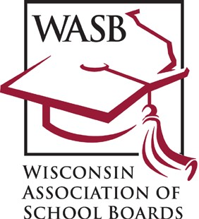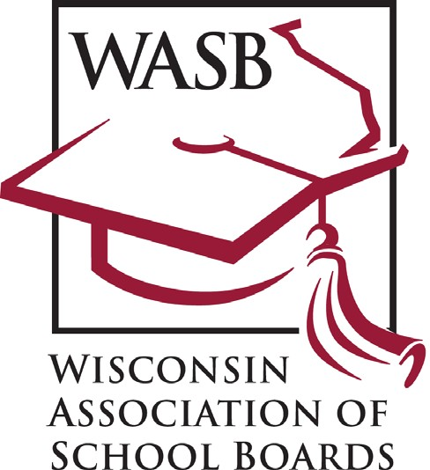

October 6-12, 2019

Contents:

▶ Tip sheet with ideas for recognition activities.

▶ Sample resolution.

▶ Sample letters to school board members’ employers to acknowledge their service to the community and emphasize school-business ties.

▶ Sample column for the district newsletter, local newspaper, website or other publication.

▶ Sample news release.

▶ Sample social media announcements.

Please note

▶ Copies of this kit can be found in PDF format at WASB.org. Look for “School Board Week”
under "Services & Resources" and then "Communication Services" on the home page.

October 6-12, 2019

Sample Activities

IN SCHOOLS
• Put a message on your schools’ marquees thanking school board members.
• Introduce school board members during halftime at a high school football game, soccer match and/or other event.
Include a message thanking them in your program or on the scoreboard.
• Invite board members to speak to social studies classes and explain the board’s role in local government.
• Design a bulletin board display featuring school board members’ photographs, background information and years of board service.

• Feature school board members in school publications and/or website.

IN THE NEWS
• Ask local newspapers and/or student newspapers to profile board members.
• Submit a guest column or opinion piece to your local newspaper on the job your board members do.
• Provide newspapers, television and radio stations with information about school boards and their special role in local governance of public schools. Provide a summary of the board’s recent outstanding achievements.

IN YOUR COMMUNITY
• Encourage the city council, village or town board, county board and/or chamber of commerce to issue an official
proclamation honoring your school board members and commemorating Wisconsin School Board Week in your
community. (See Sample Resolution.)
• Plan for a school board commendation at a staff inservice meeting.
• Seek guest appearances for board members on local broadcast programs.
• Hold a reception/reunion for former school board members.

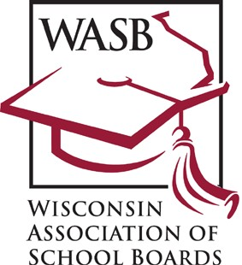Celebrate Your School Board’s Success!

October 6-12, 2019

Sample Resolution
(For use by local city councils, county boards, student councils or parent-teacher organizations.)

WHEREAS, recognizes the importance of public education in our community; and

WHEREAS, appreciates the vital role played by the local school board, which establishes policies to ensure an efficient, effective school system; and

WHEREAS, school board members serve as a voice that enables our community to preserve local management and control of our public schools; and

WHEREAS, school board members are charged with representing our local education interests to state and federal governments and ensuring compliance with state and federal law; and

WHEREAS, school board members selflessly devote their knowledge, time and talents as advocates for our schoolchildren and community's future;

WHEREAS, local school board members are strong advocates for public education and responsible for communicating the needs of the school district to the public and the public’s expectations to the district;

NOW THEREFORE, BE IT RESOLVED, that recognizes and salutes the members of the School Board by proclaiming October 6-12, 2019, as Wisconsin School Board Week.

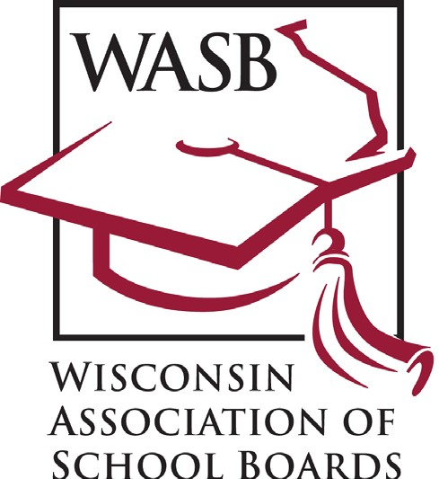

October 6-12, 2019

Sample Letter to Employer
(Send letters to school board members’ employers to acknowledge board members’ service to the community and emphasize school-business ties. To be mailed by the superintendent or Chamber of Commerce.)

Dear :

Thank you for your support of a member of the School Board.

As a member of the board, helps make decisions that have a tremendous impact on our children’s future
and the quality of life in our community. Your recognition of the importance of this civic duty and support for is
a testament to the commitment you and your company have for our community.

School board membership is one of the most personally demanding forms of public service. and the other members of the school board spend countless hours preparing for and participating in their monthly meetings. They also devote a great deal of time to studying education issues and laws and listening to the concerns of parents and teachers. In fact, they never are completely “off the job” as board members.

Wisconsin School Board Week is being celebrated October 6-12 throughout Wisconsin. I want to thank you for the important role you play in helping our school board take care of our community’s children.

Sincerely,

October 6-12, 2019

Sample Opinion Column
(This article can be adapted for use in your district newsletter, as an article in your local newspaper, as a letter to the editor, or as the foundation of a speech. Localize the article by adding information about your board, details of how board members will be honored and examples of ways your board has improved education in your district.)

The (school district name) will join school districts throughout the state to salute their local education leaders during
Wisconsin School Board Week Oct. 6-12.

The commemorative week is designed to recognize the contributions made by Wisconsin's school board members, including the (district name) School Board, who are charged with governing public education under state law.

Wisconsin school board members are chosen by their communities to manage local schools. They oversee multi- million dollar budgets which fund education programs for more than 867,000 students in more than 420 public school districts. Their personnel decisions affect thousands of teachers, administrators and support workers.

These volunteer leaders are responsible for formulating school district policy, approving curricula, maintaining school facilities, and adhering to state and federal education law. Legal concerns and the complexities of school finance, including budgeting and taxation, require them to spend many hours in board training programs and personal study to enhance their understanding of these issues.

Our deepest appreciation is extended to the dedicated men and women who make it possible for local citizens to participate in education in our community. We salute the public servants of the (district name) School Board whose commitment and civic responsibility make local control of public schools in our community possible:
(insert names of local board members)

Please join us by saying thanks to our school board members during Wisconsin School Board Week.

October 6-12, 2019

Sample News Release
(Print on school district letterhead and send to local media.)
FOR IMMEDIATE RELEASE For more information, contact: (Person’s name and phone number)

Wisconsin School Board Week set for Oct. 6-12

The Wisconsin Association of School Boards has designated Oct. 6-12 as Wisconsin School Board Week as a time to build awareness and understanding of the vital function an elected board of education plays in our communities. (Your school district name) is joining all public school districts across the state to celebrate Wisconsin School Board Week to honor local board members for their commitment to (community’s name) and its children.

“It takes strong schools to build a strong community, and these men and women devote countless hours to making sure our schools are helping every child learn at a higher level,” (superintendent’s full name) said. “They make the tough decisions every month and spend many hours studying education issues and regulations in order to provide the kind of accountability our citizens expect.”

(Superintendent’s last name) said the key work of school boards is to raise student achievement by:

• Creating a vision for what the community wants the school district to be and for making student achievement the top priority;
• Establishing standards for what students will be expected to learn and be able to do;
• Ensuring progress is measured to be sure the district’s goals are achieved and students are learning at expected levels;
• Being accountable for their decisions and actions by continually tracking and reporting results;
• Creating a safe, orderly climate where students can learn and teachers can teach;
• Forming partnerships with others in the community to solve common problems; and
• Focusing attention on the need for continuous improvement by questioning, refining and revising issues related to
student achievement.

“School board members give the (community’s name) citizens a voice in education decision making. Even though we make a special effort to show our appreciation in October, their contribution is a year-round commitment.”
The members serving our district and their years of service are as follows: (list board members here) (Conclude with the ways the district will recognize your school board members during the week.)

October 6-12, 2019

Sample Social Media Announcements
“October 6-12 is Wisconsin School Board Week”

Twitter

▶ It's Wisconsin School Board Week. We thank our school board for their hard work and leadership! (post with photo of school board)

▶ Take time to thank our school board members. It's Wisconsin School Board Week! (post with photo of school board) Tag the WASB on Twitter @wasbwi.

Facebook, Instagram, etc. (longer message)

▶ (School District Name) students benefit every day from the leadership and vision of our school board. Oct. 6-12 is
Wisconsin School Board Week so take time to thank these dedicated school leaders.

▶ School board members devote hours of their time each week to provide leadership for our school district. This week is
Wisconsin School Board Week so take time to thank a school board member today!

Tag the WASB on Facebook @wischoolboards.

